FN6814 Financial Risk Management

Assignment 1

Group 7

Delta hedging is a widely adopted strategy, and plays a pivotal role in managing risk associated with options by dynamically adjusting portfolio positions to maintain delta neutrality. It manages the directional risk of the option position by trading delta units of the underlying asset, which ensures that the value of the portfolio remains unchanged when small changes occur in the value of the underlying.

The Black Scholes model facilitates closed form expressions for the Greeks, or sensitivities of the option price with respect to input parameters in the Black Scholes model. The first section elaborates on the Black Scholes model, and behavior of Greeks in the Black Scholes world.

1. **Black Scholes Model**

For a European call option with payoff , with the strike price K, the price of the option in a Black Scholes world[1] is given as:

Where , and

The Greeks measure the sensitivity of the value of the option to changes in parameter values while holding the other parameters fixed. In particular, they are partial derivatives of the price (with the exception of Gamma, which is the partial derivative of the delta).

**Derivation of Black Scholes Delta**

, where we use the fact that and

Moreover, we use the fact that , to note that

By substituting this into the expression for we obtain:

Thus, we have the black scholes delta

**Derivation of Black Scholes Gamma**

Similarly, we obtain the gamma, which gives the sensitivity of delta to the change in stock price. Note that this is a second order sensitivity, since it takes the derivative of a greek itself.

, which gives:

**Derivation of Black Scholes Theta**

Theta measures the sensitivity of the option price to the passage of time. Note that theta can be computed on various horizons, as such we can have a 1-day theta, a 7-day or 1-week theta and so on.

Let represent the time to maturity for the option. Then we have:

Now, we note that since we have the interim result:

Note that from the earlier proof for delta, we also have the interim result

Thus, we can rewrite theta as:

Simplifying, we obtain:

**Derivation of Black Scholes Vega**

Vega measures the sensitivity of the option price with respect to the volatility of the underlying stock.

Where the first term cancels, using the fact that .

Thus, we can simplify the second term to obtain:

**Empirical Behavior**

We assume a standard European option with the following parameters for demonstration purposes:

|  | 49 |
| --- | --- |
|  | 50 |
|  | 20% |
|  | 5% |
| **(in weeks)** | 20 |
| Number of options | 100000 |

The BSM price for this option is given below:

| **BSM price** |  |
| --- | --- |
| Call Option | Put Option |
| $ 240052.73 | $ 244,817.544 |

The graph below shows the option price trend with respect to the underlying stock price.

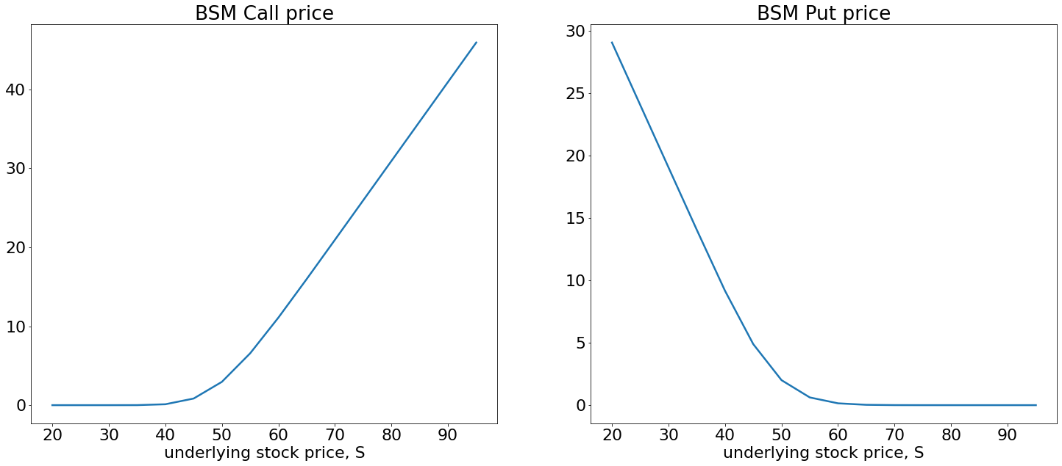

From this graph, it is easy to see that the delta of a long call option is positive, while the delta of a long put option is negative. The chart below confirms such behavior.

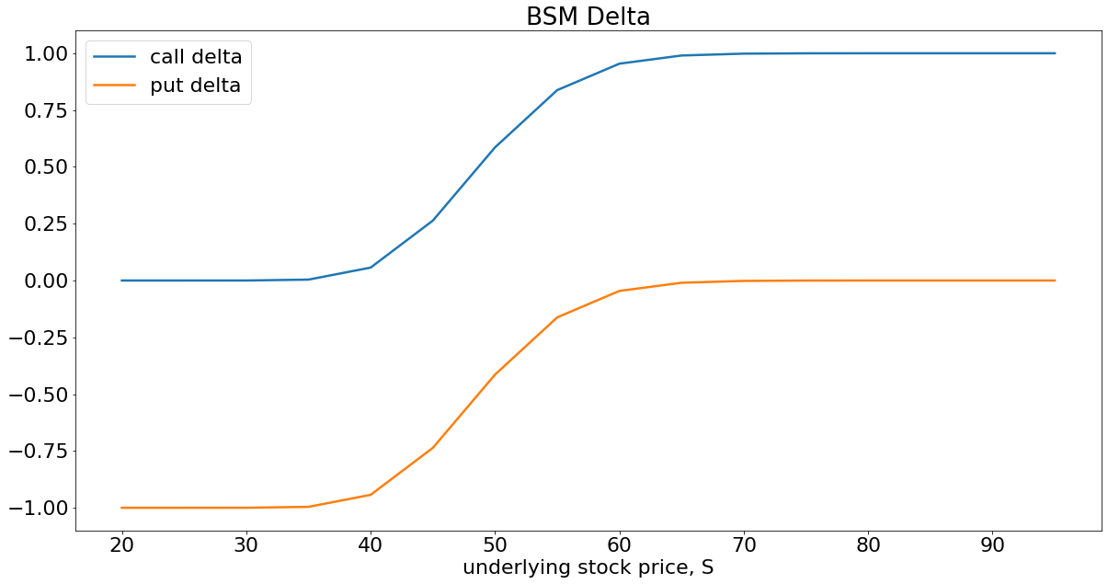

From above, we also observe the relationship between call delta and put delta:

This can also be formally derived using put-call parity to obtain the analytical equivalent. The delta for the given option at time is reported below:

| **BSM delta** |  |
| --- | --- |
| Call Option | Put Option |
| $ 52160.46 | -$ 47839.53 |

We also see the behavior of the delta with respect to passage of time. Note that with more time to maturity, there is more room for uncertainty whether the option closes in the money or out of the money, thus with more time left in the life of the option, the closer the (absolute) delta of the option is to 0.5

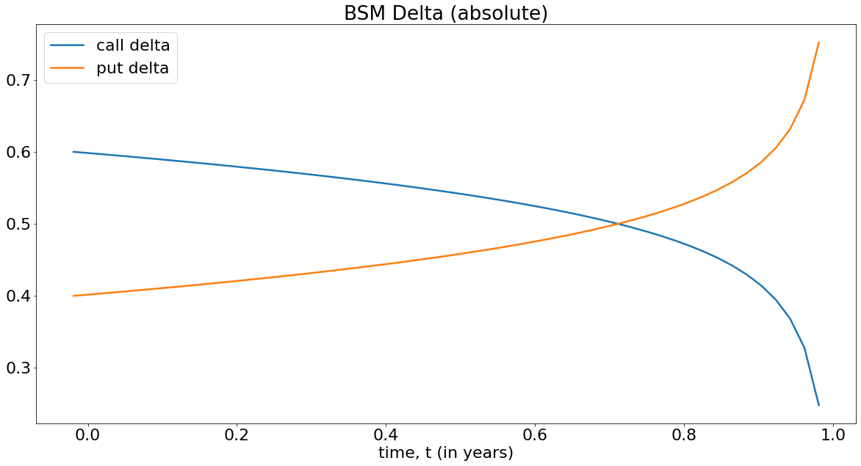

For the given option, keeping all other parameters constant, we have S = 49 and K = 50. Thus, as time passes and we approach maturity, with no change in the stock price, the call option would expire OTM, while the put option expires ITM. Thus, the call option delta approaches zero as , while the put option delta approaches -1.0 (or an absolute value of 1.0).

Such analysis explains another important characteristic: the option delta is not constant over the life of the option. Thus, the rate of change of delta with respect to the underlying is represented by Gamma.

The graph below shows the variation in gamma as a function of the underlying stock price.

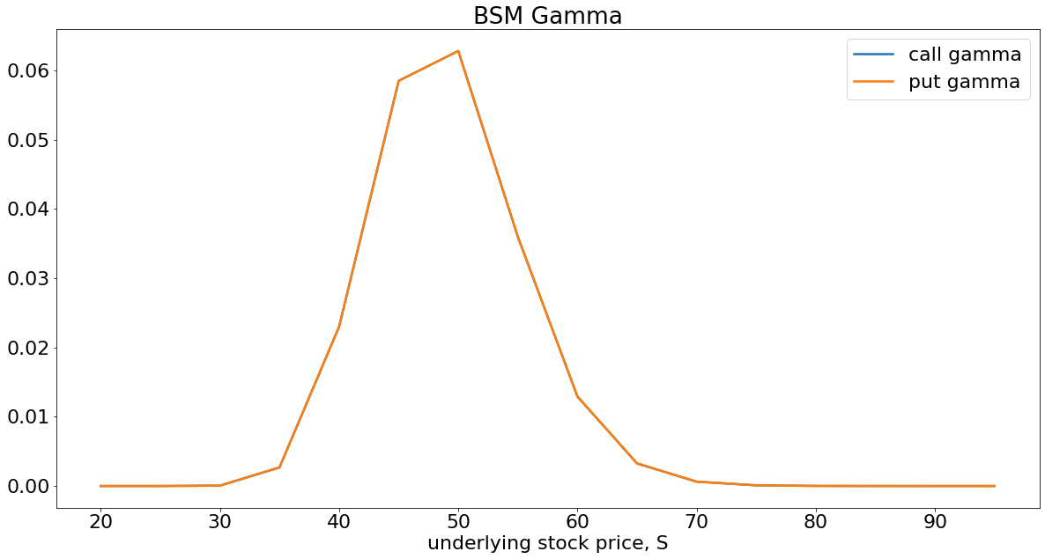

Note that the gamma for a long call option is the same as the gamma for a long put option, and both are positive. i.e., an increase in the stock price leads to an increase in option delta, and a decline in the stock price leads to a decline in option delta. We note that gamma is highest for options that are at the money (where ), since there is the most chance of variability for the ATM option to move ITM or OTM.

In contrast, deep ITM or deep OTM options have lower gamma because their deltas are less sensitive to small changes in the underlying price, and would require a larger shift in underlying to affect the delta significantly.

The gamma for the given option at is reported below:

| **BSM gamma** |  |
| --- | --- |
| Call Option | Put Option |
| $ 6554.40 | $ 6554.40 |

We also look at the theta of the option. Note that all else held constant, the more time left in the life of the option, the more valuable it is.

The option price can be split into intrinsic value and time value. The intrinsic value of the option represents the immediate, tangible value an option would have if it were exercised immediately. The time value represents the additional value attributed to the option because it has time remaining until expiration. This time value is influenced by factors like volatility, interest rate and time to expiration.

In general, as time to maturity increases, the future uncertainty about the market increases. Inversely, as time passes, this uncertainty decreases. Thus, the theta of the option is often known as time decay, and theta is usually negative for a call option.

Theta is usually large and negative for ATM options. As the stock price becomes larger, the first term in the theta expression becomes dominant, and theta tends to . Theta for puts is slightly more complex, turning positive for large values of stock price.

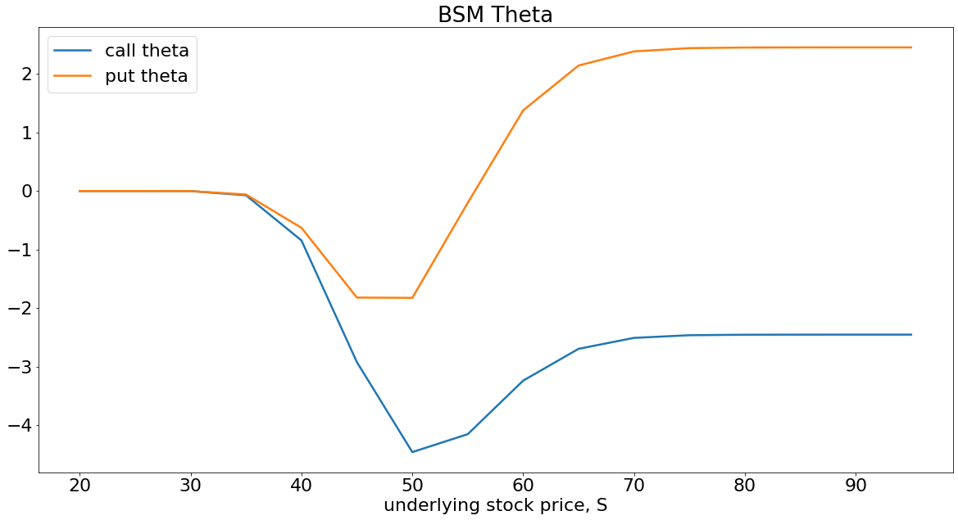

This is due to the fact that as the stock price becomes very large compared to strike price , the put option becomes less likely to be exercised because the stock price is significantly above the strike price. Thus, the time decay or theta becomes positive, as the option loses time value at a decreasing rate.

The theta for the given option is reported below:

| **BSM theta** |  |
| --- | --- |
| Call Option | Put Option |
| - $ 430532.98 | -$ 198951.97 |

Lastly, we look at the vega of the option, which is positive for both calls and puts. i.e., holding all else constant, higher volatility indicates higher option value. Vega for both the call and put option are equal.

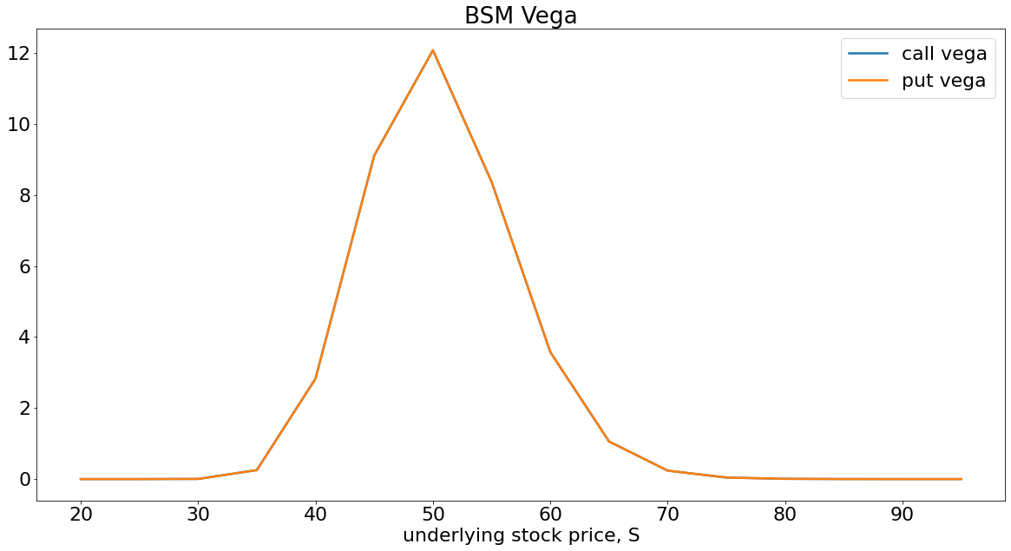

Note that implied volatility only affects the time value of an option. Since ATM options have the highest time value (since intrinsic value is 0), these options have the highest vegas.

The vega for the given option is reported below:

| **BSM vega** |  |
| --- | --- |
| Call Option | Put Option |
| $ 1210547.98 | $ 1210547.98 |

1. **Simulating Stock Prices in a Risk Neutral World**

The Black Scholes world assumes a risk neutral setting, where investors are assumed to be risk-neutral, or that they are indifferent to risk. They are not expected to be overcompensated for taking higher risks, and thus the expected rate of return on any asset, including the underlying stock is equal to the risk free rate.

Moreover, the Black Scholes model also assumes that the price of the underlying stock price can be modelled using Geometric Brownian motion, given as

Where is a constant return on the underlying asset, and is the random component. is Brownian motion and is the volatility of the underlying asset.

The derivation of E[S(t)] and Var(ln(S(t))):

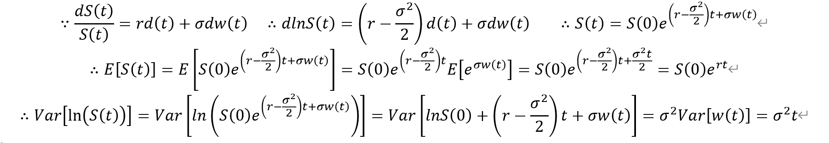

The closed form solution for the underlying asset is given as:

Where follows a log normal distribution with parameters and .

Using the fact that and increments are independent of each other, we can write by discretizing , where

Thus, we can write the stock price as:

, where

and

The graph below shows the simulated asset price paths over the 20 week period.

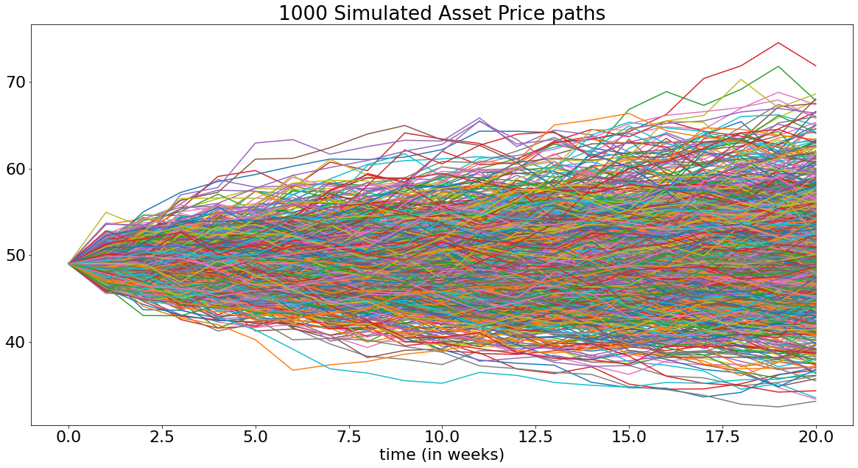

simulated share mean price is 49.94

expected mean price is 49.95

simulated log share variance is 0.02

expected log share variance is 0.02

1. **Delta Hedging and Performance**

The basic principle used to evaluate the delta hedge is that the cost of setting up the initial portfolio + borrowing + final payoff is equal to the option price. For example, Let represent the delta of a put option at time zero.

Then, the initial cost of the stock

Borrowings (for buying or selling the stock)

And the final payoff

The sum of these should be equal to the initial price of the option , and the hedging cost is computed as:

Our hedging performance are as follows (with a seed of 999 to keep the simulation result the same):

Week 20:

| **Rebalance Weeks** | 0.25 | 0.5 | 1 | 2 | 4 |
| --- | --- | --- | --- | --- | --- |
| **Hedge Ratio** | 0.12 | 0.17 | 0.24 | 0.33 | 0.47 |
| **Standard Deviation** | 23041.41 | 33047.86 | 45593.15 | 62967.54 | 89905.85 |

Week 12:

| **Rebalance Weeks** | 0.25 | 0.5 | 1 | 2 | 4 |
| --- | --- | --- | --- | --- | --- |
| **Hedge Ratio** | 0.08 | 0.11 | 0.16 | 0.22 | 0.32 |
| **Standard Deviation** | 15570.43 | 21573.21 | 30505.65 | 41564.32 | 60777.05 |

The hedging performance at the beginning (Week 12) appears to be much better compared to that in the end (Week 20). This discrepancy may be attributed to cumulative errors since the errors accumulate over time.

Different simulated volatility:

| **Simulated Volatility** | 0.1 | 0.15 | 0.2 | 0.25 | 0.3 |
| --- | --- | --- | --- | --- | --- |
| **Hedge Ratio** | 0.2 | 0.2 | 0.22 | 0.33 | 0.45 |
| **Standard Deviation** | 37850.96 | 38449.12 | 43046.18 | 62523.52 | 86171.98 |

The hedging performance exhibits a noticeable trend, where lower simulated volatility (realized volatility) results in better hedging performance compared to scenarios with higher simulated volatility.

1. The Black Scholes model assumes that the market presents no arbitrage opportunities, and presents the ability to borrow and lend (fractional) money at the constant riskless rate, buy or sell any amount of the stock and the market is frictionless (i.e., there are no transaction costs). Moreover, it assumes that the stock price follows a geometric brownian Motion and that its drift and volatility are constant